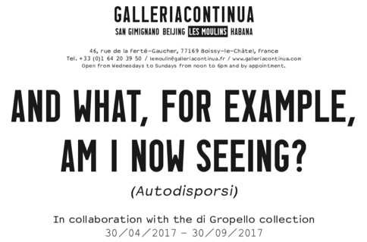

**CAPTIONS AND CREDITS**

**Of the images uploaded on casechiuse.net**

**Exhibition view**: *And what, for example, am I now seeing? (Autodisporsi)*, GALLERIA CONTINUA / Les Moulins, France, April 2017  
**Photo credit:** Rémi Lavalle (if not specified otherwise)

**Courtesy:** the artists, di Gropello Collection and GALLERIA CONTINUA, San Gimignano / Beijing / Les Moulins / Habana (if not specified otherwise)

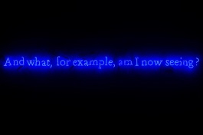

Joseph Kosuth

NR. 316 (ON COLOR) (COBALT BLUE) WITTGENSTEIN SERIES (AND WHAT, FOR EXAMPLE, AM I NOW SEEING?), 1991  
Neon, Variable dimensions  
Courtesy: Galleria Vistamare

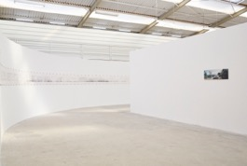

Tim Knowles

24 HOUR BALLOON DRAWING, 2002  
Ink on paper and inkjet print on aluminum  
56 x 1900 cm  
Photo credit: Andrea Pagano di Melito  
Courtesy: the artist

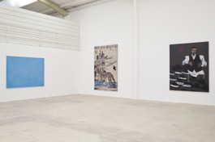

Ettore Spalletti

UNTITLED (BLUE), 1990  
Color paste on board  
170 x 229.8 x 4 cm  
Courtesy: Galleria Vistamare

Kiki Smith

CATHEDRAL, 2012  
Jacquard tapestry  
289.6 x 190.5 cm  
Courtesy: GALLERIA CONTINUA, San Gimignano / Beijing / Les Moulins / Habana

Aldo Mondino

IL CAPPELLAIO DI WILLIAMSBURG, 1990  
Oil on linoleum  
240 x 190 cm  
Courtesy: Galleria Gian Enzo Sperone

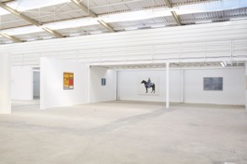

Tano Festa

DA MICHELANGELO A MONDRIAN, 1968  
Acrylic on canvas  
110 x 100 cm  
Courtesy: Tano Festa - Archivio delle opere

Gino De Dominicis

UNTITLED, 1994  
Oil on wood  
53.3 x 53.3 cm

Simone Berti

UNTITLED (KNIGHT), 2002  
Alkyd paint on canvas  
190 x 160 cm  
Courtesy: Galleria Massimo De Carlo

Alighiero Boetti

DIVINE ASTRAZIONI, 1980  
Blue ballpoint pen on paper

Diptych, 100 x 140 cm

Courtesy: Archivio Alighiero Boetti

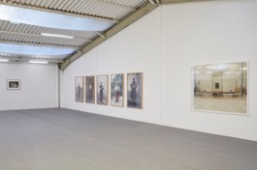

William Clift

WHITE HOUSE RUIN. CANYON DE CHELLY, 1975  
Black and white photograph

67 x 85 cm  
Courtesy: the artist

Diego Perrone

COME SUGGESTIONATI DA QUELLO CHE DIETRO DI LORO RIMANE FERMO, 2001  
Series of 5 photographs on aluminum

155 x 105 cm each  
Courtesy: Galleria Massimo De Carlo

Armin Linke

MONA LISA, 2013  
Photographic print

150 x 200 cm  
Courtesy: the artist

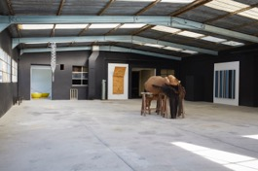

Carsten Höller

HOTEL KRUTIKOV FLIEGENDE STADT, 2004  
Plexiglas, metal  
200 x 30 x 25 cm  
Courtesy: Galleria Massimo De Carlo

Ai Weiwei

BOWLS OF PEARLS, 2006  
2 bowls of colored porcelain from Jingdezhen  
and 1⁄2 ton of clear water pearls  
Each bowl Ø 100 x 44 cm  
Courtesy: GALLERIA CONTINUA, San Gimignano / Beijing / Les Moulins / Habana

Giuseppe Gabellone

I GIAPPONESI, 2003  
Rigid polyurethane foam  
235 x 100 x 62 cm  
Courtesy: Galerie Emmanuel Perrotin

Berlinde De Bruyckere

AANÉÉN, 2003  
Polyester, metal, wood, horse skins  
180 x 300 x 160 cm  
Courtesy: GALLERIA CONTINUA, San Gimignano / Beijing / Les Moulins / Habana

Liam Gillick

REDUCED REDUCTION, 2007-2008  
Painted aluminum - unique  
200 x 192 x 15 cm  
Courtesy: Casey Kaplan Gallery

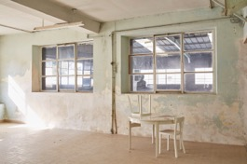

Elmgreen & Dragset

SOLITAIRE, 2002  
Table, chairs, cards  
118 x 140 x 114 cm  
Courtesy: Galleria Massimo De Carlo

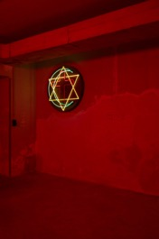

Pascale Marthine Tayou

DAVID CROSSING THE MOON, 2007  
Neon lights, iron  
Ø 110 cm  
Courtesy: GALLERIA CONTINUA, San Gimignano / Beijing / Les Moulins / Habana

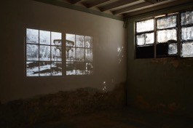

Hans Op de Beeck

LOSS, 2004  
DVD, animation film with soundscape 11 minutes  
Courtesy: Galerie Les Filles du Calvaire

**Educational workshop**

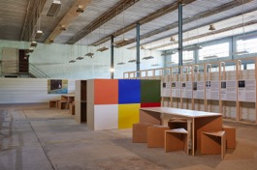

**Educational workshops with the schools**

Educational Project: Chiara Marchelli

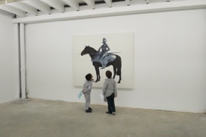 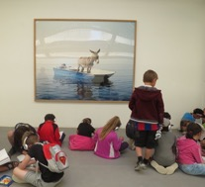

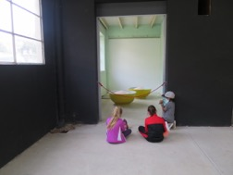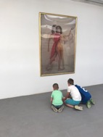

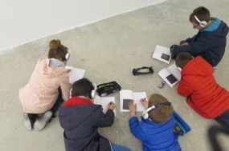 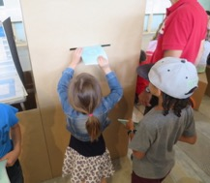

**Scans of the copybooks**

collected among the students and visitors

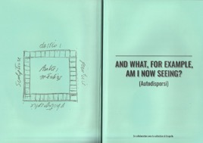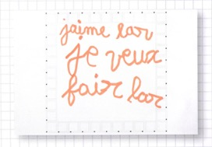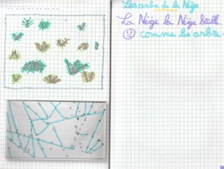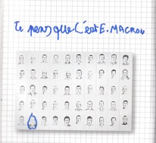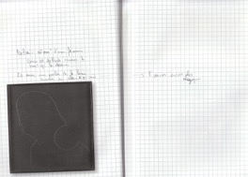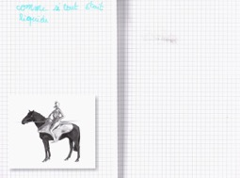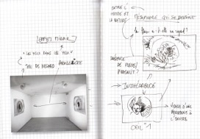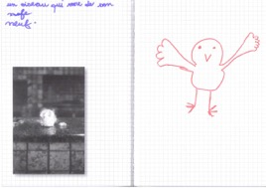

**Scans of the copybooks**

collected among the students and visitors

